PROCP TEAM MEMBERS

tRAFFIC CITY SIMUALTION SOFTWARE DEVELOPER  Fontys University Of Applied Sciences

Process report

Contents

**Process Report** 2

Project Start 2

Iteration 1: 2

Iteration 2 3

Iteration 3 3

Remarks 3

Personal Reflection 4

Work Division of each Member 6

# **Process Report**

# Project Start

The entire ProCp Project was required to make a simulation app for a company named “SIM Software”. They want us to create a city planner which can configure the roads and crossings in a city to simulate traffic and pedestrian flow during rush hour. The simulation should be able to provide the means to optimize the configuration of roads, crossings and traffic lights via statistics related to how the traffic resolves.

## Iteration 1:

The First Week it was unclear what we could do. Although we had the idea to make the app, we didn’t know what way we could approach together to make the app. After having a few discussions we came up with an idea which was to create a concrete project plan that everyone will follow. We made the use case diagram to make understand each other about the user interaction with the app.

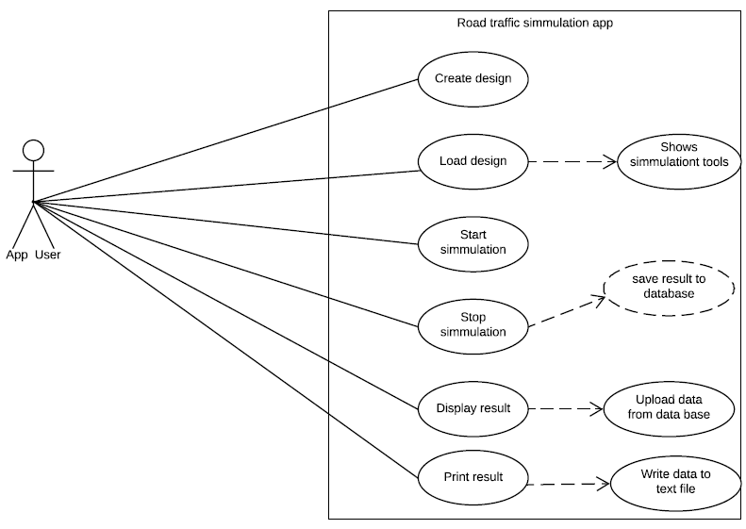

After having an idea of how the app should work we started making the use case description. Our main goal at that time was to make the documents easy for everyone to understand. Up until week 5 we made the design document and we finished our URS. We were having pretty solid goal to move on. In our app, we made the cars move after a certain period of time but it wasn’t obeying the traffic light. We put that part for our upcoming iterations. In this iteration we were missing our groupmate Sandro as he had some personal problems.

## Iteration 2

In week 8, we had our very first presentation in front of our client Mr. Basjan. He was quite satisfied with our presentation. However, he suggested us to add a value to our app so that it interests him. After having the suggestion we sat down with our tutor and got a suggestion on how to expand our app. It came as a surprise to us that we couldn’t have a solid understanding this time within our group members towards our approach. Meanwhile I(Fahim) was googling on how to make a traffic simulation app and found some quite interesting ideas. We thought it would be better if we could share what we found so that everyone gets an idea. After sharing the idea everyone was happy and they also got good learning stuffs except one of our team members. He was not satisfied as he was thinking to extend the app using waypoints. We were finding it hard to agree with him as he couldn’t show us how to work with waypoints. So, after that 4 of us started working together and made progress towards building the app and documentation. We made the drag and drop function work and also we were able to create cars and make it run in the city. Our tutor was worried about our documentation as it wasn’t on the git so we put the documents on git.

## Iteration 3

This block is the time when we were about to wrap up with our progress. After such a long period of hard work we were moving towards finishing our end goal. Suddenly our project leader came up with his waypoint idea again and modified our codes that we have written so far. Then we gave him the time to show us his code and hook up those codes to our interface. Although he deleted some of our member’s code without their consent, he was able to implement the waypoints and made the new codes work with the existing ones. We then moved on to unit testing and make design document more better. And now, We have a working app that simulates the traffic and we were trying to create a value so that our client can be convinced to buy our product. So, we thought of having data collection in our app. In other words, the app would be able to produce some data to provide the client with more clear idea of what is going on in city planner such as how many cars are in a crossing, how long does it take for a car to wait till the light is green.

## Remarks

First of all, we are all happy that our team was successful to create such a good app that simulates the traffic that solves the traffic congestion which was problem we tried to solve. Although we had a slow start and less clear vision of our goal, we were able to manage everything at the eleventh hour. It would be better if during iteration 2 our project leader would work with us. As we are students trying to learn how to work in a team, we believe that we have understood well how to work in a team. We learned from the internet and most importantly we learned from the mistakes that we made. And that’s what made us good team players. Apart from iteration 2, it was a good team work. In iteration 2, we 4 people were working which was not a good team work as we were missing our one member who was the project leader.

# Personal Reflection

**Fahim Mahmud**:

I feel that this project had a slow start and our team have managed everything just in time. We were performing very good at iteration 3. If this performance is carried on I have strong belief that we will finish every project with flying colors. This Project has taught me how to adapt in a team and how to work in diverse community. Also, I have learned how to collaborate with the team.

**Grade Expectations**: As a team If we were working like we did in iteration 3 I would expect 9.5 but as we were lacking bit of communication(Although we have learned now) I would expect at least a 7 at least as we were able to deliver the project to the client in time.

For me personally I expect a grade of 7.5. Even though two of our members were inactive for some certain periods I was active throughout the whole project. I tried my best to keep myself active in the team. Also I learned how to add value to a product which is very crucial for selling to the client.

**Dholon Akter**

At the beginning of this project, I was very curious and excited how city traffic simulation Application works. After that I have done a lot of research and sketches of our app to visualize how we can implement our application to make the best product. At the same time I did focus on URS, Class diagram and other documentations that I have found very interesting that how I can follow the Scrum methodology of Agile Software Development which follows the series of Iterations(sprints). In every iteration (around 2-3) we had to deliver the works and plan for the next iteration.In my previous project I followed Waterfall methodology where I had to complete each phase to go to the next phase for example after completing the documentation then move to the design and then implementation that was really monotonous for me.

**What I have learnt**

First of all I have learnt how to follow the project with scrum methodology that I have found myself this methodology is very effective and fun. To document of our application ,I was very active to complete the documentation with other group members. For the implantation ,initially I have done wireframe of our application then I have discussed with our group members where I have found everyone has a lot of opinions and ideas to make the interface of our application .Then I started thinking about how I can make this design graphically into our application. After that one of our group members introduced the good interface design where we have distributed the features of our application to implement.

I had a really good collaboration with team members .Every team member was very active and co- operative with each other. I have learnt how to work with multi-national people together and handle the difficult people who is not easy to convince.

**What I have found difficulties in this project**

Although we had a clear goal of our project ,In first iteration I faced a lot of difficulties organizing the project and well-structured manner. In first iteration ,it was very difficult for me to follow the project leader of our project where he was not clear concept how to coach to the members to clear their features of application and documentation. And most difficulties I faced in application where choosing the interface was very confused and lot of implementation without proper design. And I was not really clear how I can follow the features of application.

After getting discussion and lot of feedback from our tutor then we have improved our project with well-structured manner.

**Conclusion**

In conclusion I feel that I have gathered a lot of knowledge from this project how to work together and motivates to each other as well documentation and software skills .In future I will try to improve my documentation and software skills where I had lacking .Especially In application , I will try to be more proactive of the each features before waiting the other members complete and more creative way to work.And I believe that I am sufficient of this project and deserve a better score.

**Alessandro Sandor:**

I think that I started off this project pretty weak as well as all of us did, mainly because of lack of

communication and right sense of direction at the time. As the time passed we started to get a better idea of what this project is supposed to be and look like and with that I contributed more. In the middle of the whole project I had some family issues that I couldn't avoid and at that time I contributed less than I wanted. After that I tried my best to contribute every week to the best of my abilities and help others if there were any struggles. I poured a lot of time and energy into this project, all of us did, and I think that it shows especially in iteration 3. We finished this project strong but didn't start it as well and I think we all regret that now but we can learn from these mistakes and improve ourselves in the future.

If this project has taught me anything, its how to adapt to different environments and situations and how to resolve problems and improve from our previous mistakes.

**Gang Ferdinand Dinga**

For me I think the project was really interesting due to way of working which was different from the way we did with proc p.

Iteration 1

At the beginning of the project that is the first iteration we were all very excited about doing procp and as such we had several meetings as a group during which we brainstormed on the project and everybody contributed ideas about how the application should look like .

During this time there was much communication in the group. And we suceeded to deliver all the deliverables for this iteration thanks to the successive collaboration of all the team members.

Iteration 2:

During this time the group dynamics became weaker as most group members became less involved in the project and communication also became slow.We also started having some misunderstandings among ourselves .However despite all these some group members where still very committed including i just to make sure that the project does not fail.At the end of the iteration we also succeeded to deliver what was expected from us as a project team (That is a working prototype of our application and our promises for the remaining weeks or iteration)

Iteration 3:

This was the most challenging phase of the project to me because it was the final phase and there was still much to be done due to the weak collaboration we had in the previous iteration.

. Also due to disagreements the difficulties to understand each other.

Thanks to our tutor we were able to reunite and build back our self as a team again . Because of the rebuilding of the team, all the members became active again ,and there was much more communication than in the previous iteration . Every member became responsible and committed to the project more than ever before. It was thanks to this collaboration that we got to where we are now which to me i think is good as a project team.

What I learned: During this project I learned how to work in a group with people from different background, attitudes and different ideas. This to me was very interesting as I now believe that through this I was able to improve on myself as a good team player.

For the grading to me i believe we deserve a pass.

# Work Division of each Member

Dholon AKter

|  |  |  |
| --- | --- | --- |
| Iterations | Documentation | Application |
| Iteration 1 | URS draft,Meeting report,Work division Report,Project Plan | Research about Application |
| Iteration 1 | Updated URS | Made wireframe of Application |
| Iteration 2 | Design document | Tried to work on Interface |
| Iteration 2 | Updated design document with class diagram and sequence Diagram | Traffic lights and improve the comments of every functionalities |
| Iteration 2 and 3 | Updated final version Of URS | Class Diagram |
| Iteration 2 & 3 | Updated final version of work division reports | Sequence Diagram |
| Iteration 2 & 3 | Updated final version of design document | Statistics Interface |
| Iteration 3 | Updated final version of process report | Statistics Implementation |

Fahim Mahamud

|  |  |  |
| --- | --- | --- |
| Iteration | Documentation | Application |
| Iteration 1 | Improved the project plan | Application Research |
| Iteration 1 |  | Interface of Application |
| Iteration 2 | URS,Design Document | Making cars move on the screen |
| Iteration 2 | Updated URS and design document | Drag and dropping Application |
| Iteration 3 | Process report draft | Class Diagram |
| Iteration 3 | Updated final version of URS and Design document | Sequence Diagram |
|  |  |  |

**Gang Ferdinand Dinga**

|  |  |  |
| --- | --- | --- |
| Iteration | Documentation | Application |
| Iteration 1 | Project plan draft first version | Research on Application |
| Iteration 1 | Updated the final version of Project Plan. | Made prototype of Application  Design GUI and |
| Iteration 2 | Created the use case  diagram for the application.  Work division  Assisted the project leader | Traffic lights interaction with car in simulation |
|  | URS,Design Document  Made the first presentation | Class Diagram |
| Iteration 3 | Process report update. | Drag and drop by adding a table layout panel  Create cars on the crossing  Create traffic lights  Implement the serialisation |
|  | Final presentation | Made charts in statistics  Implement bar chart for visualisation |
|  |  |  |

**Alessandro Sandor:**

|  |  |  |
| --- | --- | --- |
| Iteration | Documentation | Application |
| Iteration 1 | Improved the final version of Project plan | Application research |
| Iteration 1 | Updated Use Cases | Worked on drag and dropping  crossing application(some part) |
| Iteration 2 | Updated design document | Helped to make Interface |
| Iteration 3 | Updated Class Diagram | Unit testing |
|  | Updated the Process report |  |
|  |  |  |
|  |  |  |

**Alex**

|  |  |  |
| --- | --- | --- |
| Iteration | Documentation | Application |
| Iteration 1 | Improved the final version of project plan | Research on Application |
| Iteration 1 | Use Case(discussion) | Idea of Waypoints to work on Application |
| Iteration 2 | Class Diagram | Interaction between car and traffic light |
| Iteration 2 |  | Starting the Application |
| Iteration 3 |  | Stopping the Application |
| Iteration 3 |  | Usuability of Application |
| Iteration 3 |  | Improve statistics |